**PYTHON: GETTING STARTED**

# Course Overview

## Course Overview

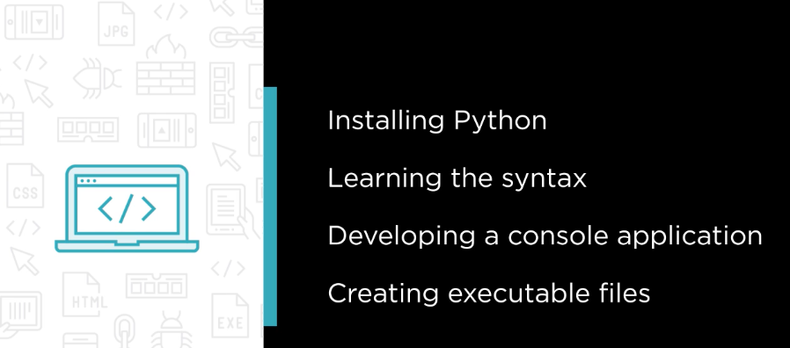

# Introduction

## Introduction

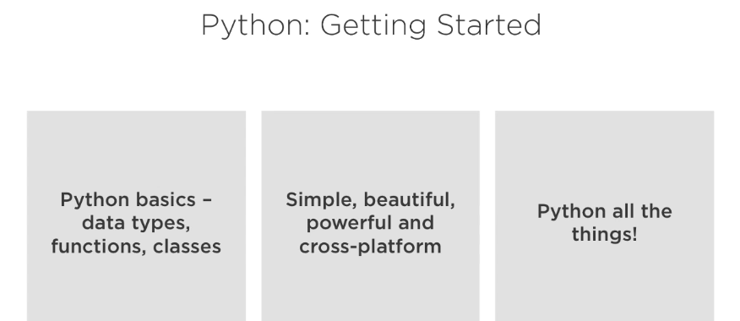

## What Makes Python so Amazing?

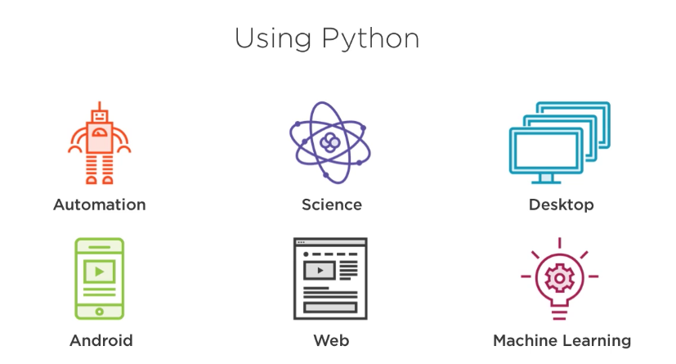

## Python 2 vs Python 3?

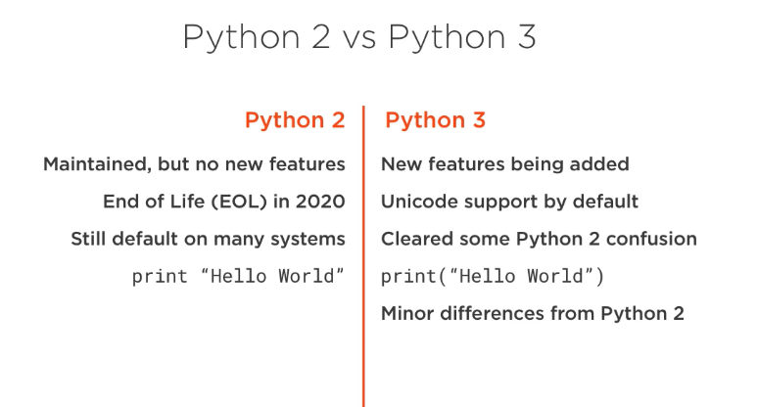

## Installing Python

## The Awesomeness of the Python Console

## Installing PyCharm

# Types, Statements, and Other Goodies

## Introduction

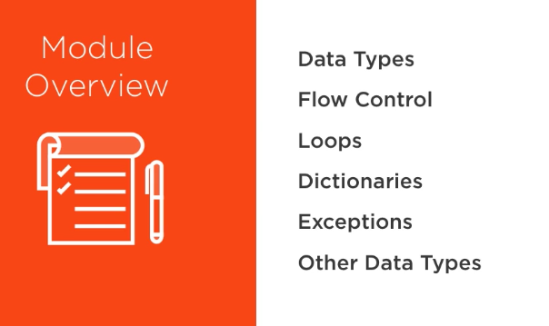

## Types in Python -wait, What?

## Integers and floats

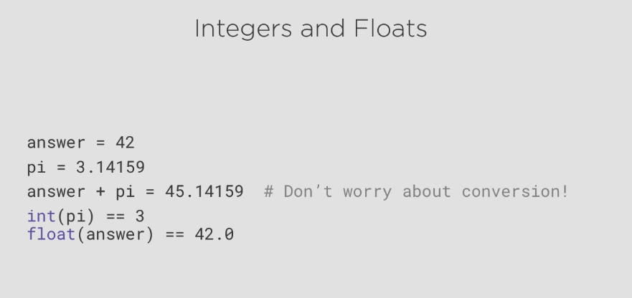

## Integers and floats

## Strings

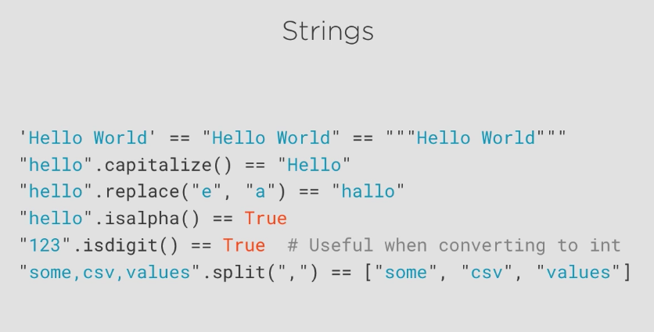

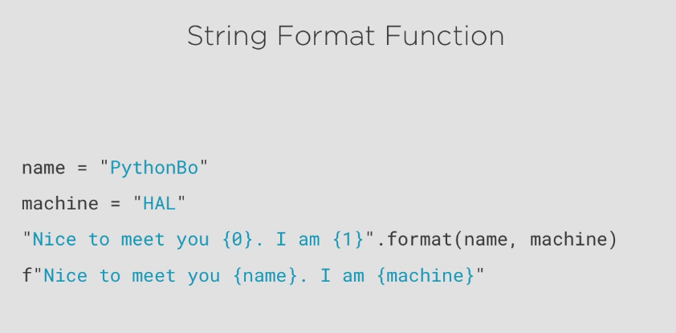

## Boolean and None

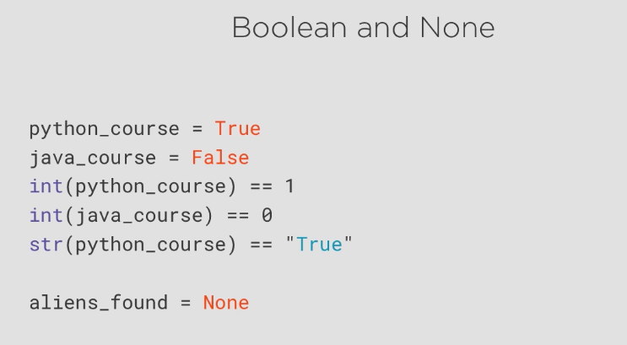

## If Statements

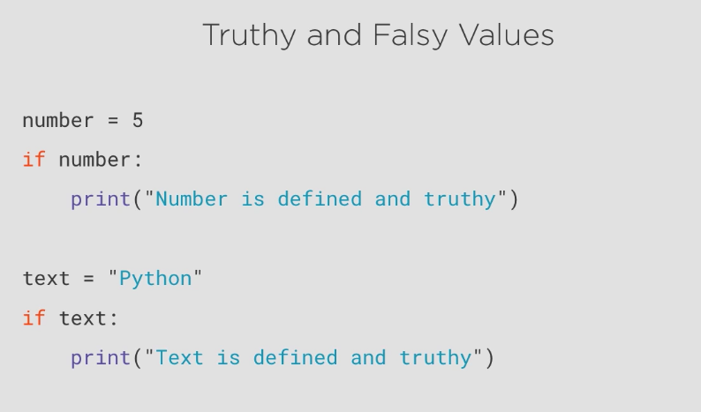

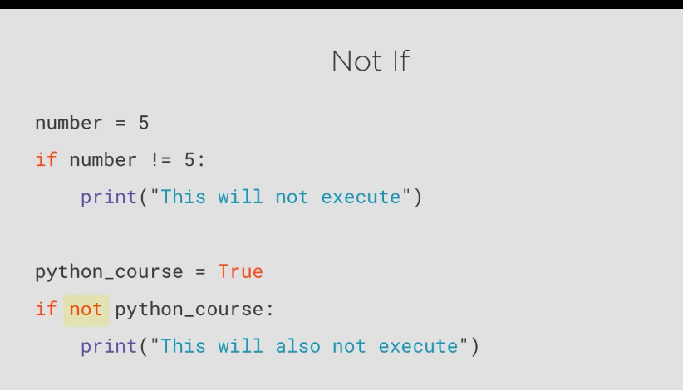

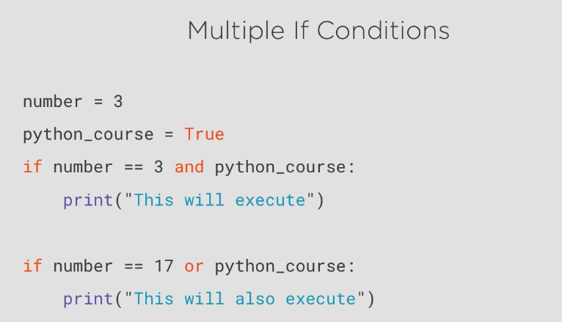

## Lists

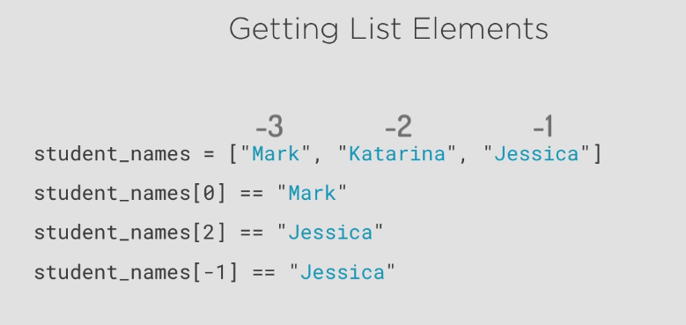

* Adjust elements List

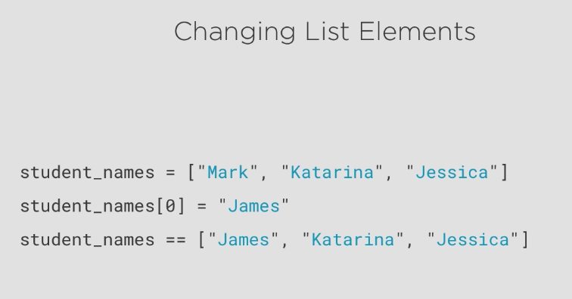

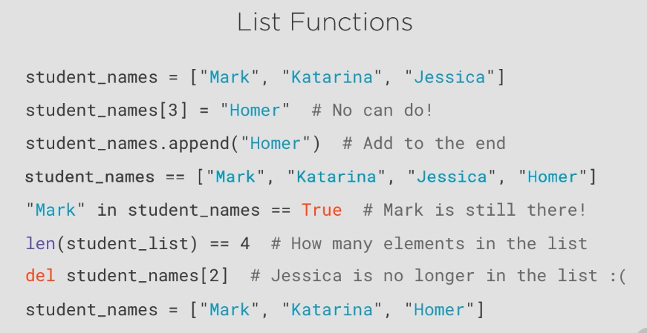

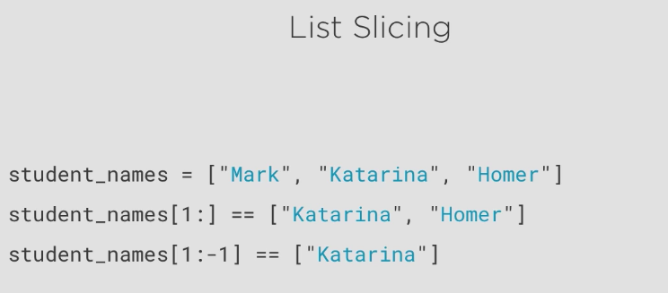

## Loops

## Break and Continue

## While Loops

## Dictionaries

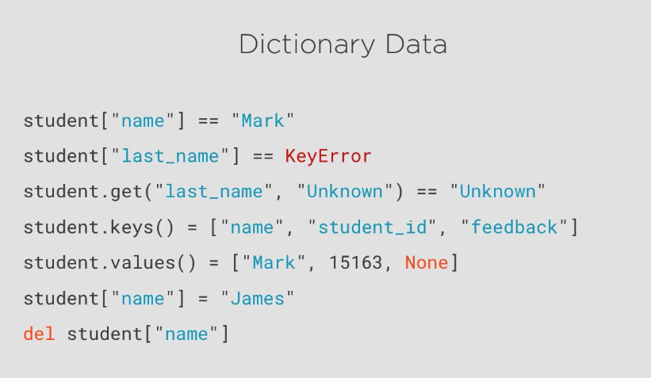

## Exceptions

## Other Data Types

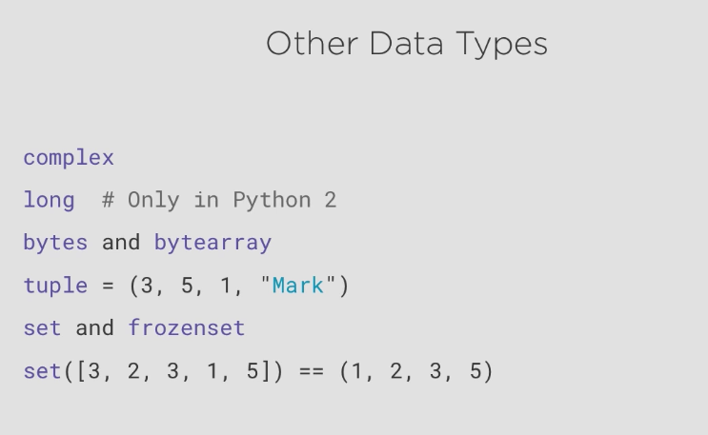

## Summary

# Functions, Files, Yield, and lambda

## Module Overview

## Our App- PyStudentManager

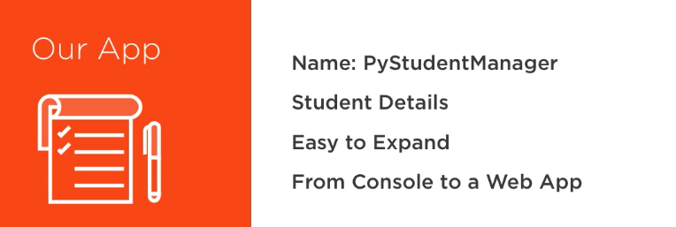

## Functions

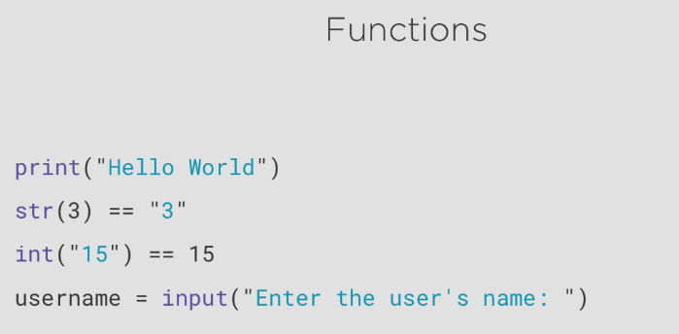

## Function Arguments

## Adding Students to Our App

## Nested Functions and Closures

## Opening, Reading, and Writing Files

## Yield

## Lambda Functions

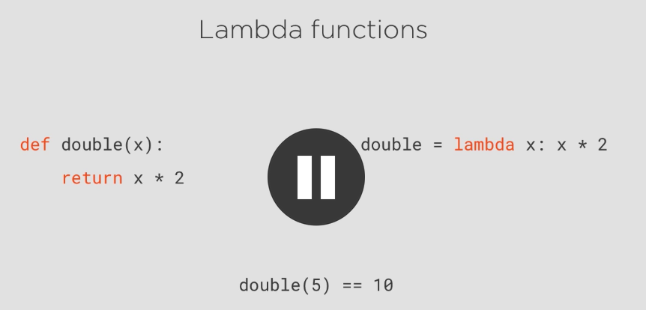

## Summary

# Object Oriented Pragramming – Classes and why do we need them?

## Module Overview

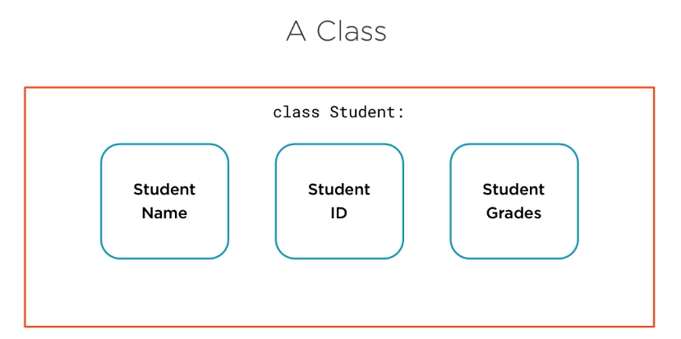

## Classes and why do we need them?

## Defining a class in Python

## Adding Methods to Our Class

## Constructor and other special Methods

## Instance and class attributes

## Inheritance and polymorphism

## Breaking our app into modules

## Comments

## Summary

Review again

# Putting it All Together – Let’s Make it a Web app

## Module Overview

## Installing python packages and flask

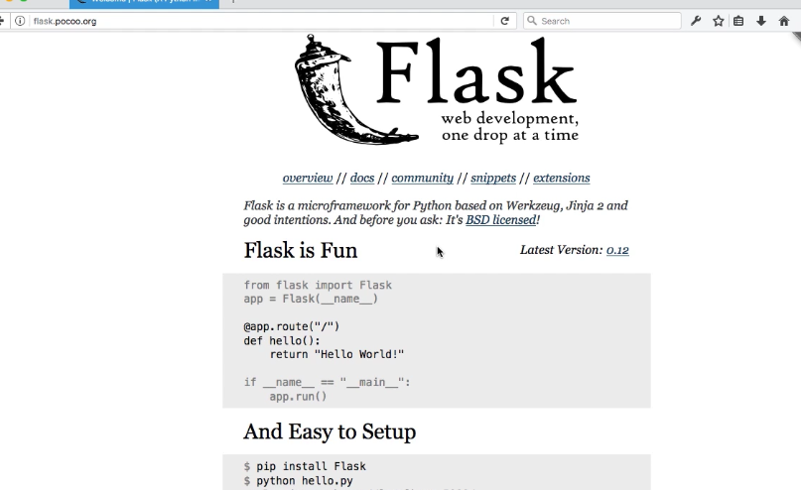

## Making our app a web app

## How much code did we share?

## summary

# Python Tips and Tricks

## Module overview

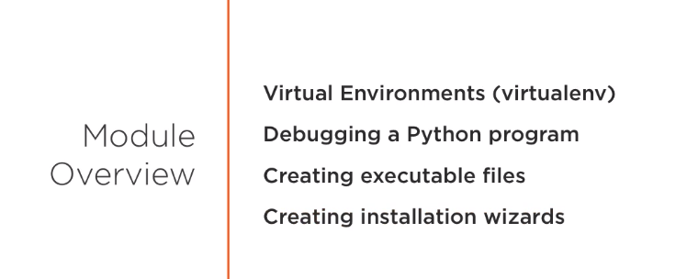

## Working with virtual environments

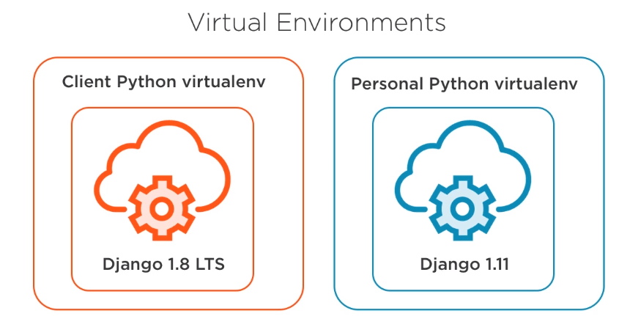

## Debugging python code

## Creating an executable file form a python app

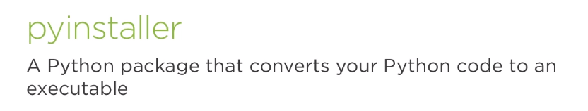

## Creating a setup file

Using inno setup compiler

## Course conclusion